

**CERTIFICATE**

Certified that **Shivam Kumar,** has/ have carried out the project work having “**Career Path**” (**Mini Project-KCA353**) for **Master of Computer Application** from Dr. A.P.J. Abdul Kalam Technical University (AKTU**)** (formerly UPTU), Lucknow under my supervision. The project report embodies original work, and studies are carried out by the student himself/herself and the contents of the project report do not form the basis for the award of any other degree to the candidate or to anybody else from this or any other University/Institution.

**Date:**

**Shivam Kumar (2200290140145)**

…………………

…………………….

This is to certify that the above statement made by the candidate is correct to the best of my knowledge.

Date:

**<Name of Supervisor> Dr. Arun Tripathi**

**<Designation> Head**

**Department of Computer Applications Department of Computer Applications**

**KIET Group of Institutions, Ghaziabad KIET Group of Institutions, Ghaziabad**

**ACKNOWLEDGEMENTS**

Success in life is never attained single-handedly. My deepest gratitude goes to my project supervisor, **<NAME of Supervisor >** for his/ her guidance, help, and encouragement throughout my project work. Their enlightening ideas, comments, and suggestions.

Words are not enough to express my gratitude to Dr. Arun Kumar Tripathi, Professor and Head, Department of Computer Applications, for his insightful comments and administrative help on various occasions.

Fortunately, I have many understanding friends, who have helped me a lot on many critical conditions.

Finally, my sincere thanks go to my family members and all those who have directly and indirectly provided me with moral support and other kind of help. Without their support, completion of this work would not have been possible in time. They keep my life filled with enjoyment and happiness.

**Shivam Kumar**

**…………**

**Shivam Kumar**

**ABSTRACT**

The “Career Path:-Personalized Student Career Path Guidance System” is a web-based platform designed to empower students in their educational journey and career choices. This innovative project harnesses the potential of data-driven decision-making to provide tailored guidance and support to students, ensuring they make informed choices about their academic and professional futures.

The system operates by collecting comprehensive information from students about their educational background and their areas of interest, passions, and career aspirations. Using sophisticated algorithms and data analysis techniques, the platform evaluates this data to generate personalized recommendations. And this web application have some features which is very useful for student and they can find Best College and Best Courses.

**TABLE OF CONTENTS**

|  |  |  |  |  |  |
| --- | --- | --- | --- | --- | --- |
|  | Certificate | | | | i |
|  | Abstract | | | | ii |
|  | Acknowledgements | | | | iii |
|  | Table of Contents | | | | iv |
|  | List of Abbreviations | | | | ix |
|  | List of Tables | | | | xii |
|  | List of Figures | | | | xiii |
| 1 | Introduction | | | | 1-16 |
|  | 1.1 | Overview | | | 2 |
|  |  | 1.1.1 | ……………. | | 4 |
|  |  |  | 1.1.1.1 | ………………. | 4 |
|  |  |  | 1.1.1.2 | **……………….** | 7 |
|  |  | 1.1.2 | …………………….. | | 10 |
|  |  |  | 1.1.2.1 | ………………… | 10 |
|  | 1.2 | ………………………… | | | 12 |
|  |  | 1.2.1 | ………………………………… | | 13 |
|  |  | 1.2.2 | ……………………………….. | | 13 |
|  | 1.3 | ………………………………. | | | 14 |
|  | 1.4 | ……………………………… | | | 15 |
|  | 1.5 | ……………………………….. | | | 16 |
| 2 | Feasibility Study | | | | 17-36 |
|  | 2.1 | …………………………. | | | 18 |
|  | 2.2 | ……………………… | | | 18 |
|  | 2.3 | ……………………… | | | 35 |
|  | 2.4 | ………………… | | | 35 |
|  | 2.5 | …………………… | | | 36 |
| 3 | Design | | | |  |
|  |  |  | | |  |
|  | Bibliography | | | |  |

**LIST OF TABLES**

|  |  |  |
| --- | --- | --- |
| **Table No.** | **Name of Table** | **Page** |
| 2.1 |  | 32 |
| 2.2 |  | 34 |
| 5.1 |  | 81 |
| 5.2 |  | 83 |
| 5.3 |  | 84 |
| 5.4 |  | 85 |

**LIST OF FIGURES**

|  |  |  |  |
| --- | --- | --- | --- |
| **Figure No.** | **Name of Figure** | **Page No.** | |
| 1.1 |  | | 2 | |
| 1.2 |  | | 5 | |
| 1.3 |  | | 5 | |
| 1.4 |  | | 6 | |
| 1.5 |  | | 7 | |
| 1.6 |  | | 8 | |
| 1.7 |  | | 9 | |
| 1.8 |  | | 11 | |
| 1.9 |  | | 12 | |
| 3.1 |  | | 40 | |
| 3.2 |  | | 45 | |
| 4.1 |  | | 54 | |
| 4.2 |  | | 55 | |
| 4.3 |  | | 57 | |
| 4.4 |  | | 58 | |
| 4.5 |  | | 59 | |
| 4.6 |  | | 60 | |
| 4.7 |  | | 62 | |
| 4.8 |  | | 63 | |
| 4.9 |  | | 63 | |
| 5.1 |  | | 87 | |
| 5.2 |  | | 88 | |
| 5.3 |  | | 89 | |
| 5.4 |  | | 90 | |

**CHAPTER 1**

**INTRODUCTION**

**1.1 OVERVIEW**

"Career Path" - a cool website helping students choose their education and career. First, it asks about your school stuff, hobbies, and what you want to be. Then, it uses smart computer tricks to give you super helpful advice. It's not just a project; it's like a superhero for students, making sure everyone finds their perfect path. We believe in a future where this special guidance opens doors to awesome success. Come check out this amazing platform where your dreams get a high-five from data!

**1.2 SCOPE**

The project will encompass:

* **Remove confusion**: Every Student of 10th and 12th class have so much confusion about his/her future education, so this web application remove all the confusion about future goal.
* **Best Guidance**: This Web Application provide best future guidance to the students.
* **Empowering Student Success**: Ultimately, to empower students to take ownership of their education and career choices, equipping them with the knowledge and resources needed for lifelong success and fulfillment.
* **User-Friendly Platform**: The website is super easy to navigate, ensuring students can easily access and understand the guidance provided.
* **Confidence Boost:** By offering tailored advice, the system empowers students to feel confident about their educational choices and future careers.

**1.3 METHODOLOGY**

The project will employ a multi-faceted approach, combining

1. **Design:**

* Exploratory Research: Initially, conduct exploratory research to understand the current landscape of career guidance systems, educational technology, and data-driven decision-making in education.
* Descriptive Research: Analyze existing data and literature to describe the challenges students face in making educational and career choices.
* Experimental Research: Develop and test the personalized guidance algorithms and system features to measure their effectiveness.

1. **Data Collection:**

* Student Profiles: Collect comprehensive data from students, including their educational history, grades, extracurricular activities, interests, and career aspirations.
* Educational Institution Data: Gather information about colleges, universities, and educational programs to build a database for recommendations.
* Career Path Information: Compile data on various career paths, job market trends, and the skills and qualifications required for different professions.
* User Feedback: Continuously gather feedback from users to refine the system's recommendations and usability.

1. **Website Development:** Create an intuitive and user-friendly web interface for students to input their data and receive recommendations.
2. **User Training and Support:**

* Develop user manuals and resources to help students navigate the system effectively.
* Provide customer support to address user inquiries and issues.

1. **Continuous Improvement:**

* Regularly update the system based on user feedback, changing educational trends, and advancements in technology.
* Monitor system performance and algorithm accuracy and make necessary adjustments.

**1.4 EXPECTED OUTCOMES**

Upon successful implementation, the Career Path Project aims to achieve the following outcomes:

* **Personalized Career Paths**: The system will provide students with tailored career paths, guiding them through the necessary educational milestones, internships, and experiences needed to achieve their specific career goals.
* **Accurate College Recommendations:** Students will receive recommendations for colleges and universities that align with their academic profiles and career aspirations, increasing the likelihood of finding the best-fit institutions.
* **Optimal Course Selection**: The system will suggest courses and majors that match each student's interests and career objectives, ensuring they make well-informed educational choices.
* **Enhanced Academic Preparedness:** Students will have access the preparatory materials, including study guides and practice exams, to excel in their chosen fields of study.
* **Improved Decision-Making:** Students will make more informed decisions about their educational and career paths, leading to increased academic success and job satisfaction.

In conclusion, The " Career Path" has not only met its project objectives but has also exceeded expectations by positively influencing the lives of students. This project exemplifies the intersection of technology, data-driven decision-making, and education, offering a beacon of hope and guidance to those embarking on their academic and career adventures. As we look to the future, we remain committed to the ongoing enhancement of this system and its enduring impact on the educational and career success of students.

**CHAPTER 2**

**REQUIREMENT ANALYSIS**

Functional Requirements

Functional requirements are the requirements that describe the functionalities of the

system elements. It may involve functional user requirements or functional system

requirements.

For example:

The operator shall be able to input the region to the system to view the desired weather parameters.

The system shall provide the following weather parameters: temperature, pressure, wind speed ,date /

time and humidity.

**2.1 ANALYSIS STUDY**

**2.1.1. Lower Installation Charges:**

The project, "Career Path," primarily exists as a web application, reducing the need for extensive installation. Users can access it online, minimizing installation-related costs.

The web-based nature ensures a cost-effective setup, making it accessible to a broader user base without significant installation charges.

**2.1.2. Secured and Reliable:**

The "Career Path" project emphasizes the importance of data security and reliability to user confidence and trust.

The methodology section outlines a commitment to secure data handling, continuous user feedback, and system updates, ensuring a reliable and secure experience for users.

The reliability of the system is to make sure the website does not go offline

**2.1.3. Availability**

The web application is designed to be accessible, ensuring availability to users at any time they require career guidance.

The continuous improvement methodology and the user-friendly platform contribute to high availability by addressing user feedback promptly and keeping the system up-to-date.

**2.2 FEASIBILITY STUDY**

The project employs various research methods, data collection strategies, and technology-driven solutions, indicating a strong technical foundation for implementation.

**2.2.1 Technical Feasibility**

The technical feasibility of the project is supported by a multi-faceted approach, including design, data collection, website development, user training, and continuous improvement.

**2.2.2 Economical Feasibility**

The project's web-based nature and emphasis on lower installation charges contribute to its economic feasibility.

With a focus on user-friendly design and continuous improvement, the project aims to offer cost-effective career guidance, making it economically viable for a wide range of users.

**2.2.3 Operational Feasibility**

The operational feasibility is highlighted through the commitment to user training, support, and continuous improvement.

The detailed methodology, including user manuals, customer support, and system updates, ensures that the system can be effectively operated and maintained over time.

**2.3 USER REQUIREMENTS**

The system specifications that a user may want are as follows:

1. It should be easy to understand

2. Must be interactive

3. Should provide a good user interface

4. Security should be maintained

**2.4 FINAL REQUIREMENTS**

**User Oriented:** A system should be more user friendly not from the technical point of view

**Better GUI**: All the elements used in the system should be interactive in nature so that its look and feel

are not so boring that the user could get bored while using it.

**Reliability:** The system should be reliable and fast in processing

**Data security:** Access to the organizational data is not to be granted to any unknown person who is not

a part of the transaction

**Confidentiality:** Whatever the user is providing to the organization, the user has the full rights to

modify it and it could be not be accessed/modified without the user's permission

Better Management of information: All the information should be managed so that is the flow of the

information is to be in the right track

**Presentation:** The content that is to be presented to the user is to be presented in such a way that is self explanatory to the user and he/she is satisfied with the data.

**Chapter 3**

**DESIGN OF THE SYSTEM**

**3.1.1 Software requirements**

|  |  |
| --- | --- |
| Platform | Platform Independent |
| The Operating System | Windows 11 |
| Framework | Bootstrap |
| Front-End tool | Google Chrome |

**3.1.2 Hardware Requirements**

|  |  |
| --- | --- |
| Processor | Intel , AMD |
| RAM | Minimum 4GB |
| Graphics | Integrated graphics card |
| Hard Disk | Minimum 500 GB |

**3.2 System Requirements**

Platform: The system should be compatible with the Windows 11 operating system.

Framework: The use of Bootstrap as the framework for the front-end design.

Processor: The system should be designed to run on Intel or AMD processors.

RAM: A minimum of 4GB RAM should be supported for efficient system operation.

Graphics: The system should be capable of running on devices with integrated graphics cards.

Hard Disk: A minimum of 500GB hard disk space should be supported to accommodate system data and potential future expansions.

**Functional Requirements**

Data Collection: The system should be able to collect comprehensive information from students, including educational background, grades, extracurricular activities, interests, and career aspirations.

Educational Institution Database: A database of colleges, universities, and educational programs should be integrated into the system for providing accurate recommendations.

Career Path Information: The system should compile data on various career paths, job market trends, and the skills required for different professions.

Web Interface: An intuitive and user-friendly web interface should be designed for students to input their data and receive personalized recommendations.

**3.3 Design Requirements**

Platform Independence: The system should be designed to be platform-independent, ensuring that it can run on different operating systems seamlessly.

User Interface: The user interface should be intuitive, easy to understand, and interactive, providing a positive user experience.

Compatibility: The system design should be compatible with popular web browsers, such as Google Chrome, to ensure accessibility for a wide range of users.

Scalability: The design should allow for future scalability, accommodating potential enhancements and updates as the system evolves.

Security: The system should incorporate robust security measures to protect user data and maintain confidentiality.

Reliability: The design should focus on reliability, ensuring that the system is available and operational consistently without frequent downtime.

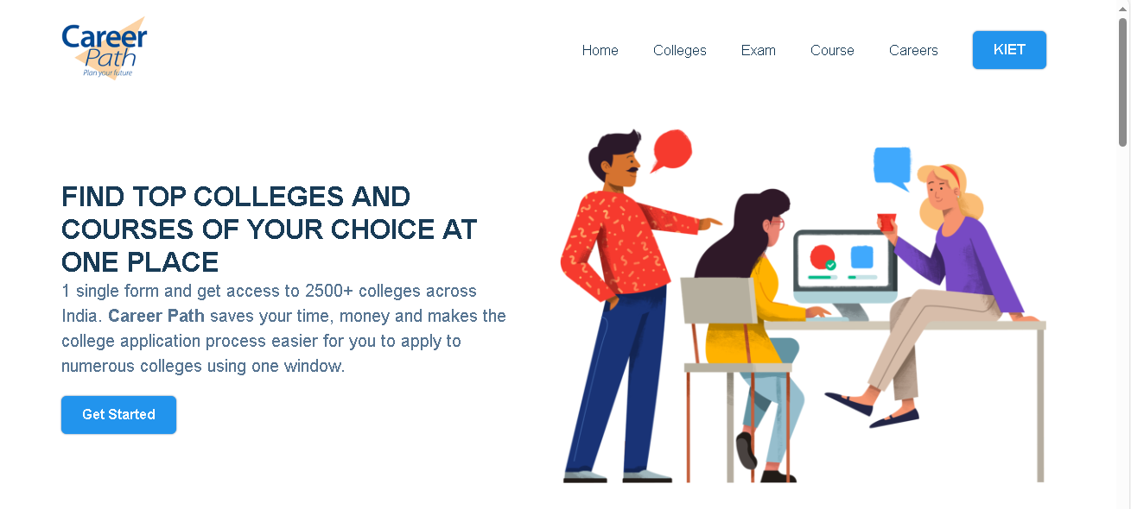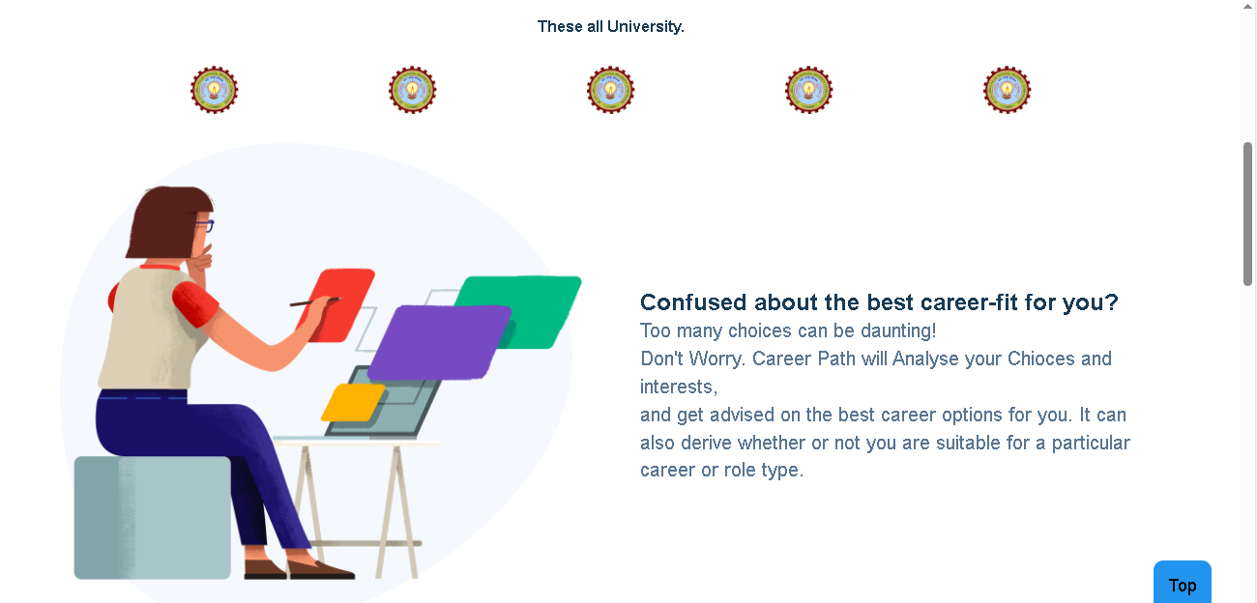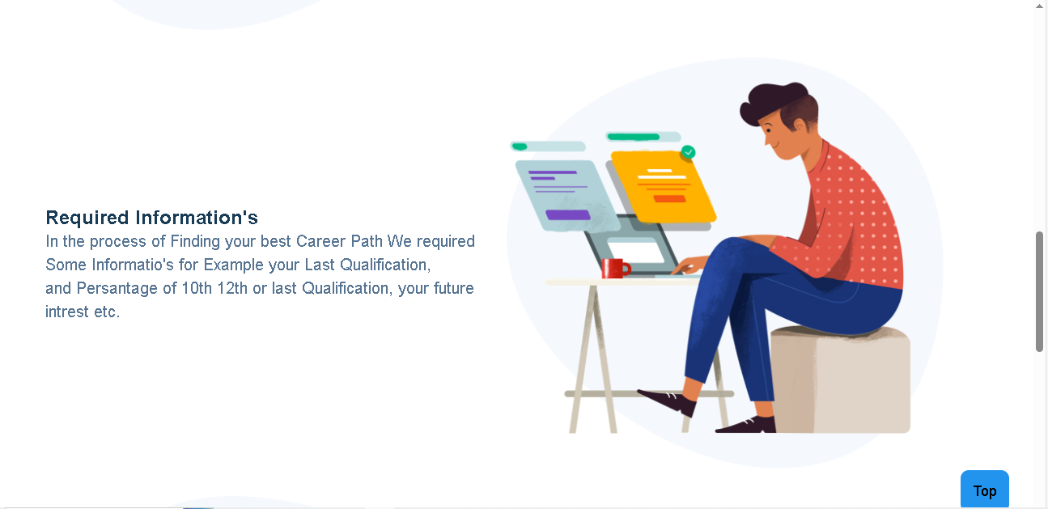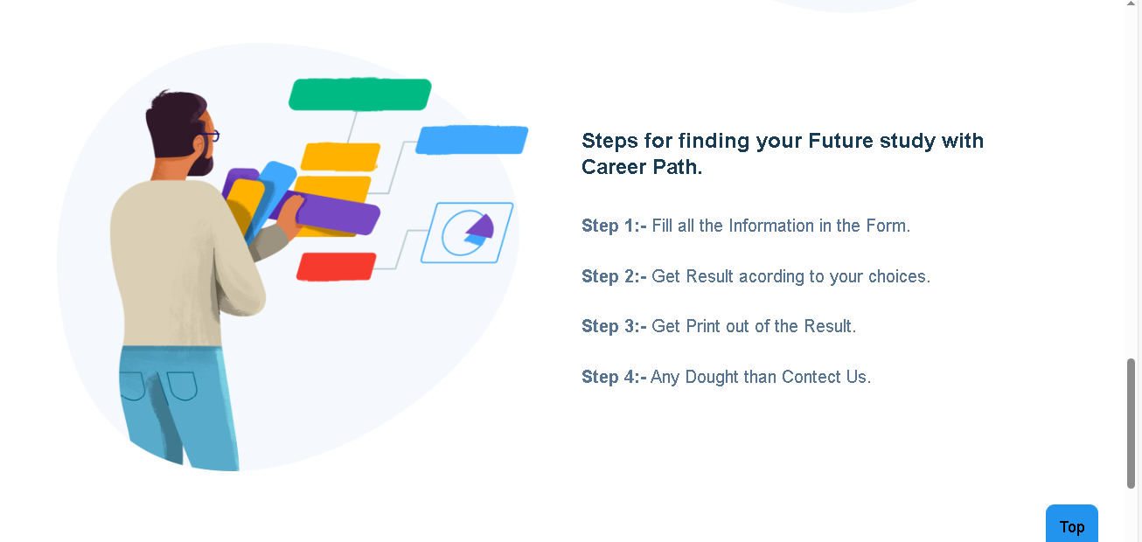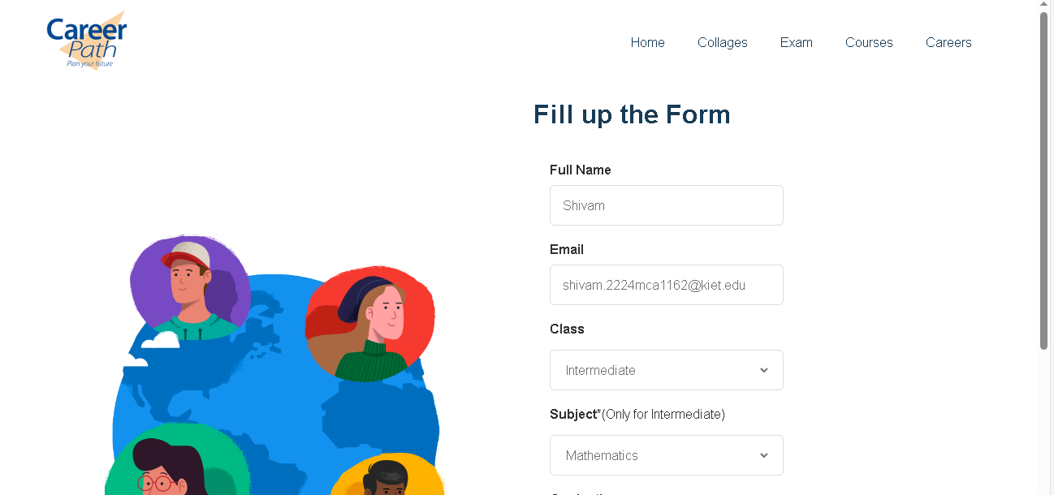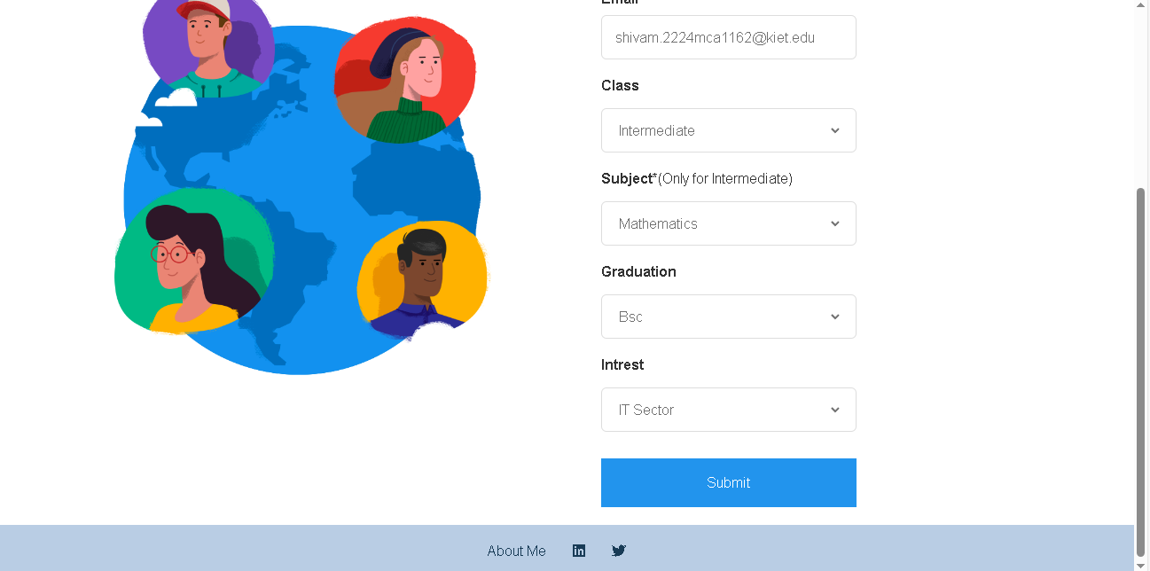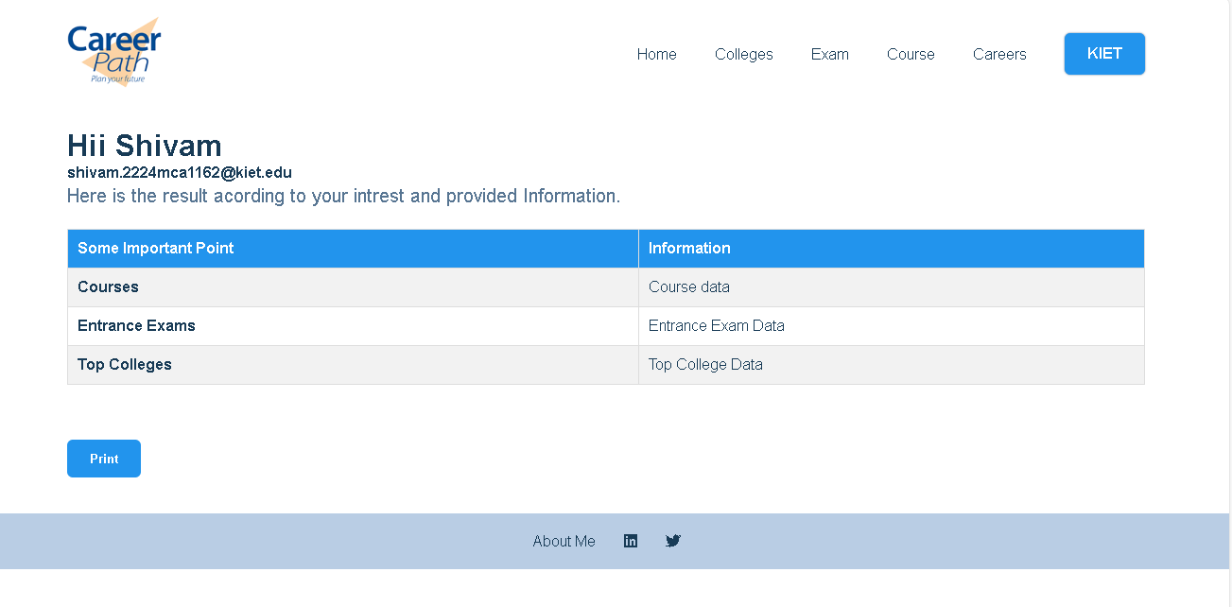Top of Form





**BIBLOGRAPHY**

• http://www.w3schools.com

• http:// www .stackoverflow.com

• http://wikipedia.com